Internet-Of-Things Accident Detection System, Using Arduino And The Cloud

*Please do not modify this text block unless you receive explicit instructions.*

*CMP3753M Project*,

Proposal/Work in Progress Document.

Grateful thanks goes to the ACMSIGCHI Extended Abstracts format on which this is based. <https://sigchi.github.io/Document-Formats/>

# Abstract

Author

Craig Penning

Student ID: PEN14541450

University of Lincoln

School of Computer Science

14541450@students.lincoln.ac.uk

According to the World Health Organisation, traffic accidents are the 8th leading cause of deaths globally, with 1.35 million people dying each year due to road traffic-related accidents (2018, p21). This is a crisis needing an imminent solution, otherwise, these statistics will continue and consequently cause more people to lose their lives. This project evaluates if the Internet-of-Things (IoT) is a viable solution to this problem. By using sensors to detect and send accident data to the cloud, this project aims to understand if sensor data could be utilised in real-time by emergency response units.

# Author Keywords

Internet-of-Things (IoT); Networking Technologies; Cloud Computing; Arduino; Sensors and Actuators; Big Data; Telematics.

# Introduction

According to the Department of Transport Statistics, in 2018 there were 122,635 total reported accidents across all roads, with 1,671 of these reported accidents resulting in fatalities (Department for Transport, 2019). This project aims to understand if it is possible that networking and cloud technologies are a potential solution in reducing these statistics.

The number of connected IoT devices was predicted to reach 50 billion by 2020, although now current experts predict this value to be between 17-30 billion devices (IEEE Spectrum, 2016), this is broken down further per device in figure 1. Likewise, IoT has been recognised to have had an impact on the quality of life and businesses (Buyya and Dastjerdi, 2016, 7). This project aims to understand what similar impacts IoT can have through the addition of IoT based features in cars. Furthermore, the infrastructure would be required to make this idea feasible.

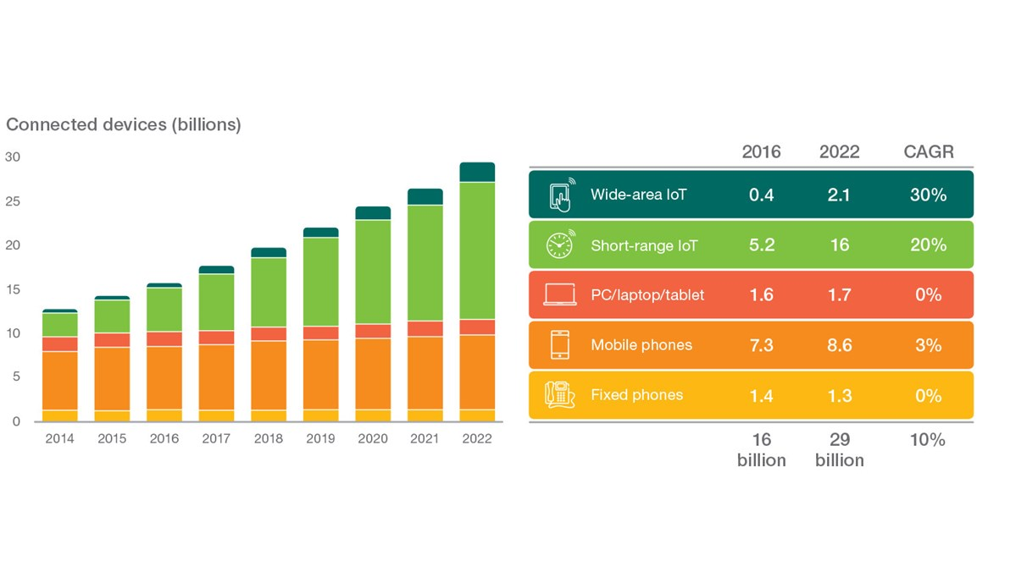Tesla cars have incorporated ultrasonic sensors, light detection and ranging (LiDAR) sensors, and cameras into their autopilot technology (Tesla, 2019). The range of this technology also offers the ability to detect and alert the driver of an impending accident (Fingas, 2016), which is important as this could reduce the damage caused by traffic accidents. Ultrasonic sensors like those used by Tesla will be used within the artefact.

**Figure 1**: Prediction for connected devices by 2022 (Ericsson, 2019)

This project will simulate a small-scale car using an Arduino board as a miniature Electronic Control Unit (ECU), “a device that controls one or more electrical systems in a vehicle…The ECU provides instructions for various electrical systems, instructing them on what to do and how to operate.” (Computer Hope, 2017). The Arduino board will be connected to multiple sensors that will record; the speed of the car, the distance from an object, and the GPS coordinates of the car. These features together will allow the car to be capable of detecting when it is about to crash and, with an additional Wi-Fi shield, record the data to the cloud.

# Aims and Objectives

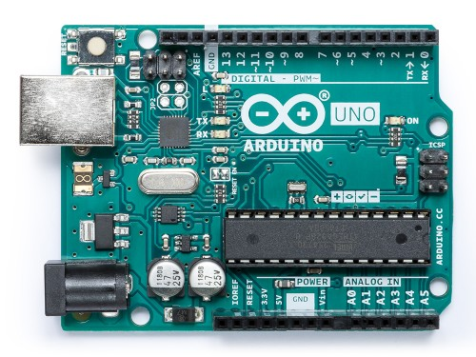

**Figure 2**: Arduino Uno Board

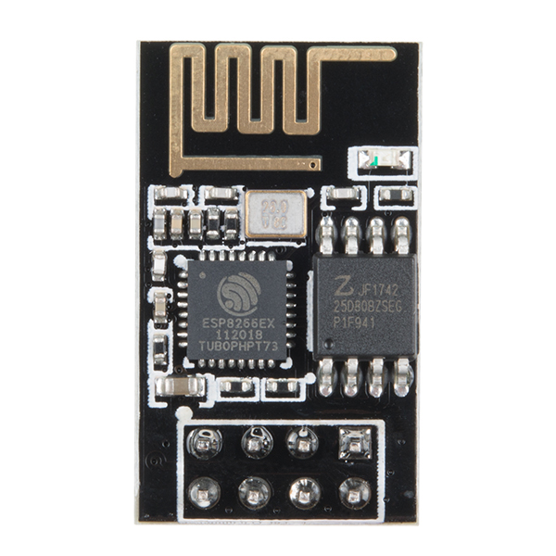

**Figure 3**: ESP8266 WiFi Module

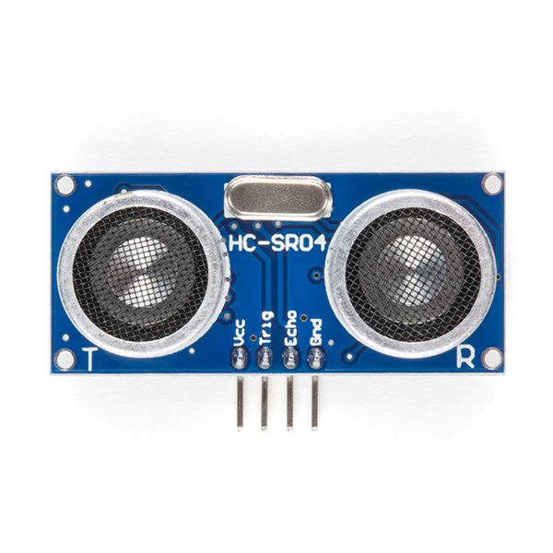

**Figure 4**: HC-SR04 Ultrasonic Sensor

Aim:   
To develop and evaluate an IoT device’s capabilities in vehicle hazard detection, and further analyse the collected results.

Objectives:   
1. Continue to conduct a systematic examination of the problem through analysis of currently published sources. The literature considers research from the comparative fields of networking, cloud, and IoT technologies.  
2. Develop a suitable IoT device using microcontroller boards.  
3. Develop a Cloud solution through an iterative software development process that meets the project’s requirements.  
4. Collect quantitative data from the IoT device through controlled environment scenarios, then test/plot the data for valuable information.  
5. Evaluate the data against existing data provided by the government.  
6. Analyse the results and collate key insights

# Literature Review

To understand the requirements and capabilities of the project, an abundant amount of research needed to be undertaken in the following fields; IoT, Cloud computing, and Networking.

Greengard states that “designing and building systems that truly work in the real world-and deliver maximum value-is remarkably difficult” (2015, 111). Following from this he lists multiple areas where an IoT devices can fail both technically and in a practical sense for example; interruptions to internet access, and physical component failures. If the IoT artefact produced from this project suffers some of these issues it could cause the artefact to be unable to record accident data.

Many academics have researched the concept of a connected car, a car that is able to access the internet via mobile phone networks (Kawtar and Tomader, 2019). Häberle et al describes a prototype platform for the connected car with application templates that provide the architecture for telematics application prototypes. The architecture used is a modified three-tier architecture purposed around enabling user-vehicle interaction. This journal is built from Christoph Fehling’s design process that utilises patterns, “structured textual documents that describe abstract problem-solution pairs to design problems recurring in a specific context.” (Fehling, 2014).

These patterns are designed to cover the problems cloud developers come across when designing, building, and managing applications that are based in the cloud. Häberle et al were able to successfully develop their platform for research and development groups. Furthermore, they found that these patterns offered reusable functionality which aided with the speed of development and also served as a guideline based on how the patterns reference each other. Häberle and his colleagues also pointed out how Fehling’s design process is limited in that “the patterns cover how to use cloud offerings but not how to actually build a cloud. This is because they target application developers and not cloud providers” (Häberle et al, 2015).

Following on from this, Marosi et al also suggest a platform for a cloud based framework for a connected car platform. The paper lists two different iterations of the cloud framework, the first is an Infrastructure-as-a-Service (IaaS) model deployed on OpenNebula based cloud, whilst the second is a “private Platform-as-a-Service (PaaS) IoT cloud built on the Cloud Foundry Platform within the premises of an automotive company” (Marosi et al, 2018). The purpose of the paper was to see if functionalities like eco-driving (optimising driving habits through driving data) and weather forecasting could be implemented into a car from the cloud.

To understand the technology required to make the project idea feasible, **Networks Basics Companion Guide** by Cisco Networking Academy provides examples of hardware, protocols, and services involved in networks. One of the important aspect of the artefact is connecting to networks and sharing data which is underpinned in this book. The information provided by this book will outline the technology that can work in co-operation with the artefact and explain the technology required to make the idea both scalable and consequently feasible.

Likewise to understand the problem fully, the World Health Organisation’s **Global Report on road safety in 2018** goes into detail about the statistics of road safety, targeting current challenges and suggesting preventative legislation to reduce risk. This literature presents the information plainly, allowing the adaptation of these ideas by whomever may wish.

# Project Plan

**Figure 5**: Gantt chart made using officetimeline.com

## **Project Plan**

The project plan encompasses all of the main objectives required to complete this project. The project is expected to last 6-8 months starting from September 28th and ending on April 2nd. A section of allotted time has been set up in late April which is dedicated to presenting the project in front of academics. As a project management strategy, the Gantt chart has been broken down into separate manageable sections which take into account the deadlines for each assessment and the difficulty of each task. In addition to this, the second objective will be broken down into four manageable sprints to ensure that each component of the artefact is functioning whilst having enough time to reflect and improve on the artefact where necessary. At the end of each section, demonstrated through the change in colour on the Gantt chart, there will be a reflection period to see if the progress made is on par with the schedule, or behind schedule.

## **Work in Progress Document**

The work in progress document, labelled in green on the Gantt chart, is a document which assesses; the progress achieved so far in the project, the underlying risks of the project, the aims and objectives of the project, understanding the reason behind the project existence, and the value that this project provides.

Work Packages:

* Introduction – Explains the background and rationale for carrying out the project and sets out why the project is relevant and beneficial to the field of Computer Science.
* Aims and Objectives – Explains the aim of the project and the objectives which must be met in order to achieve this aim. The aim is decomposed into a series of objectives which, when met, will contribute to achieving the stated aim.
* Academic Literature – A review of at least five pieces of literature that have been identified as being directly relevant to the project. It will establish the context and rationale for the study and confirm the choice of research.
* Project Plan – A documented plan, in the form of a Gantt chart, which encompasses the whole of the timeframe for the project and shows timescales and milestones for achieving each of the project objectives.
* Risk Analysis – Identify and explain the specific risks associated with the project, along with the likelihood and assessed impact on each risk. This should also set out how each risk might be managed and mitigated.
* Review of Progress – Note the current progress of the project such as; what objectives have been met, what methodologies are being implemented into the artefact, have issues arisen with the project, etc.

## **Develop and Iteratively Test Artefact**

Labelled in red, a large portion of the project will be dedicated to building the hardware side of the artefact, developing the software code to run the artefact, and developing cloud IaaS/PaaS code to set up a cloud vendor to work in conjunction with the physical artefact. During this stage of the project, there will be continuous iterative testing, using agile software development methodologies, to ensure each component of the artefact is functional and can work alongside the other features.

Work Packages:

* Design Arduino Device – Use a schematic diagram software like Fritzing to draw how each component will be connected to the Arduino board. Design can be iteratively changed as the needs of the artefact change.
* Build Arduino Device – Purchase and connect each component to the Arduino board according to the schematic diagram. Once the device has been assembled it will be attached to the RC Car using a non-static material like Blu-tack.
* Code Arduino Device – Using the Arduino Integrated Development Environment (IDE), iteratively build the code through agile coding methodologies like SCRUM. As each component code is built, attach it to the Arduino board and see if it outputs expected results. Then repeat the software development process till the artefact has been fully built.
* Code Cloud Platform – Decide a cloud provider most suitable for the project, then develop the cloud platform wither through the GUI console, command-line interface, or deployment manager. Using the same iterative cycle, develop each core part of the cloud platform; storage, virtual machines, APIs, etc.

## **Collect and Analyse Data**

The period of time labelled in yellow on the Gantt chart is dedicated to collecting test data by setting up controlled environments where accidents are more likely to occur (unexpected bends, unexpected obstacles such as pedestrians, etc.). This data will then be analysed to see if it can be turned into useful information i.e. coordinate values that can be plot onto a map in real-time.

Work Packages:

* Set up test environments – Find and purchase materials that are able to simulate road conditions and road obstacles. With these materials set up scenarios or cases where an accident would be likely to occur i.e. an unexpected sharp turn.
* Complete multiple tests – Using the test environments, crash the RC car to collect and send data to the cloud for storage.
* Data visualisation – Plot the data stored in the cloud, using the data’s longitude and latitude coordinate. Give each data point additional labels, for example, speed of the RC car.

## **Literature Review**

Throughout the project, labelled in blue, there will be a thorough literature review that analyses different books, journals, and conference papers regarding each aspect of the project. This includes topics from microcontroller boards to cloud vendors and IoT devices. The literature review will also take place during the final report, this is because during the report it may become apparent that there are better resources to use or may provide an alternative and/or critical view on a specific subject.

Work Packages:

* Conduct examination of published sources – Examine the problem through analysis of currently published sources. The literature considers research from the comparative fields of networking, cloud, and IoT technologies. This will be an ongoing process throughout the project.
* Write up notes on each piece of literature – Break down sources into manageable notes which clearly explains the purpose and findings of each source.

## **Analyse the results and collate key insights**

The penultimate aspect of the project will be the summation of all work carried out on the project. Furthermore, it will be evidenced as a report detailing; all of the literature relevant to the project, methodologies involved with developing the artefact, results returned from tests, and more. Importantly this final dissertation report will be the culmination of research, through academic theory work and also practical software development. This component of the project is highlighted in the light blue colour of the Gantt chart and has been given 5 days’ worth of time. This is because all demonstrations are occurring only within the week commencing 20th April.

Work Packages:

* Infer from data – Use the collected data to see what information can be retrieved and how this information could be used by emergency services.
* Collate findings along with research – Compose all information including; literature review, methodology, result from findings into one coherent document.

## **Demonstrate Project and Artefact**

The final aspect of the project will be to demonstrate the artefact to academic peers who will assess the quality of the work carried out. This is labelled in cyan on the Gantt chart.

Work Packages:

* Create presentation – Develop a slide show which simplifies, yet incorporates, all the research from the project.
* Further develop artefact – If there is time, work on the artefact further to improve its features or add more functionality.

# Risk Analysis

**Figure 6**: Risk Matrix by Steve Highley (Highley, 2018). Note: The risk matrix has a minor error, the Unlikely-Minor box should be 4 instead of 2.

|  |  |  |  |  |
| --- | --- | --- | --- | --- |
| Risk Identified | Risk Explained | Risk Likelihood and Impact | Risk Impact | Risk Management/Mitigation |
| Electrostatic Discharge (ESD) | ESD could cause the Arduino components to damage and not function properly. Caused by a buildup of static charge. | L:5  I:5  RM: 25 | ESD could damage and kill potential electrical components, this would delay the schedule for building the artefact due to purchasing and waiting for replacement parts. | All Arduino component handling will be on top of an ESD mat, and any person involved with the components will wear an ESD band to ground the wearer and prevent any ESD from occurring. In the event that the risk does happen, new components will be purchased if there is evidence of significant damage. |
| Arduino Coding issues | Issues with the software development of the artefact (i.e. unfamiliar with the IDE interface/coding language) | L:3  I:2  RM: 6 | Coding problems could be problematic as it could delay the final build which would reduce the amount of time for testing and collecting data. | Allocate more time to the coding portion of the artefact. Research the language used by Arduino and how it is implemented. Use coding forums to solve common coding errors (for example stackoverflow.com). |

|  |  |  |  |  |
| --- | --- | --- | --- | --- |
| Risk Identified | Risk Explained | Risk Likelihood and Impact | Risk Impact | Risk Management/Mitigation |
| Arduino components not working | The component fails to work/does not function properly. | L:2  I:5  RM: 10 | New components would need to be purchased to replace old ones. This would likely cause a delay to the artefact building process. | Ensure backup components are available. Ensure all safety measures are in place to avoid ESD damage (ESD Mat, ESD Wristband). Only buy from reputable sellers like sparkfun.com. If seller is unavailable/doesn’t sell component, alternative sellers will be used. |
| Arduino components unfit for purpose | The component is unable to perform specific tasks required for the artefact. | L:1  I:5  RM: 5 | New component would need to be purchased, or will be cut from the project altogether (depends on the component). | Research each components capability before purchase and only buy from reputable sellers like sparkfun.com. If component purchased doesn’t fit requirements then a different component will be purchased |
| RC car too big/small | If RC car is too big then the test will be harder to achieve due to lack of available space to drive. If RC car is too small then the Arduino components won’t fit onto the body. | L:5  I:3  RM: 15 | New RC car will need to be purchased which will increase cost of project. | Research RC car sizes and reputable brands. If RC car is too big/small, new one will be purchased that better fits the size requirements. |

|  |  |  |  |  |
| --- | --- | --- | --- | --- |
| Risk Identified | Risk Explained | Risk Likelihood and Impact | Risk Impact | Risk Management/Mitigation |
| RC car breaks | RC car breaks and is no longer usable for testing. | L:2  I:5  RM: 10 | New RC car will need to be purchased or new method of testing the Arduino device will need to be considered | Come up with backup ideas in case RC car breaks or buy a new RC Car. Only test device in specific controlled environments where the risk of damage is unlikely. |
| Cloud vendor, does not offer suitable services for project | Cloud vendor does not have IoT based features and/or big data features. | L:1  I: 4  RM: 4 | Different cloud vendor will need to be chosen for the project. | Research heavily into different cloud providers and their services, e.g. Google Cloud Platform, Microsoft Azure, etc. If cloud provider doesn’t offer suitable services, shut down all resources and transfer the project to a different cloud provider. |
| Cloud vendor unavailable | The cloud vendor (Google Cloud Platform, Microsoft Azure, etc.) is down and features do not work. | L:1  I:5  RM: 5 | If the cloud vendor is unavailable then the cloud aspects will not work. | Wait for service to come back online. Invest in multiple cloud vendors. Work on other features of the project while the cloud vendor is unavailable. |

# Review of Progress

The project is ahead of schedule, the Arduino components and RC car were scheduled to be obtained in December. Instead, this objective has been completed within September and November. The work in progress document itself is coming along faster than anticipated, the first draft was expected to be finished by mid-November but is instead weeks ahead in schedule and should be expected to be done before the second week of November.

Through personal research, the cloud vendor has been narrowed down between Google Cloud Platform (GCP) and Microsoft’s Azure. Both vendors’ offer free tiers, GCP gives users $300 worth of credits to spend (Google Cloud, 2019). Alternatively, Azure has a program for students that provides $100 free credit and access to powerful tools like SQL Server 2017 Developer Edition (Microsoft, 2019). Prior experience exists with GCP and for this reason, it may be the vendor best suited to this project.

Many methods of representing both the dataset, and test data have been identified, such as using machine learning as a tool, however, significant drawbacks have been spotted, and so further research needs to be undertaken. Fortunately, another method of representing the data has been identified using Google Maps, which allows users to plot the data based on longitude and latitude coordinate values. This method will not only act as a way to visualise the data but will also help pinpoint where accidents occur in the UK.

Arduino is an open-sourced microcontroller platform designed for enthusiasts, originally developed as an aid for teaching students (Monk, 2016, 1-6). Arduino accredits itself as “easy-to-use for beginners, yet flexible enough for advanced users” and can be evidenced by the fact that Arduino has been used in thousands of different projects and applications (Arduino, 2019).

Although there is personal unfamiliarity with the C language, the programming paradigms module has taught that many concepts carry over between languages, unless that language is of a separate paradigm altogether. This means that knowledge acquired from C++ can be transferrable to C due to their similarities.

Arduino has its own platform for developers to host their creations and source code, this means that there are many solutions to common Arduino code problems already on the internet. For example, during the artefact design phase, many requirements were identified, such as needing a speedometer to determine speed. Because all Arduino designs are available under a Creative Commons License (Monk, 2016, 7), a solution was discovered relating a bicycle instead of am RC Car.

On the other hand, setting up controlled environments to collect data is a cause of concern for this project. Simulating a road means that extra care will need to be taken to ensure that materials are sourced to provide accurate results. As the RC car only has a one-speed setting, this project is unable to test bends at different speeds without human engagement, which would impact on the resulting data output regardless. This is something that can be explored through future research.

# References

Arduino (2019) *Arduino Uno*. Arduino. Available from: <https://store.arduino.cc/arduino-uno-rev3> [accessed 8 November 2019].

Arduino (2019) *Arduino* – *Introduction.* Arduino.Available from: <https://www.arduino.cc/en/Guide/Introduction> [accessed 16 November 2019].

Buyya. R. Dasjerdi, A.V. (eds.) (2016) *Internet of Things: Principles and Paradigms*. Amsterdam: Morgan Kaufmann.

Computer Hope (2017) *ECU.* Computer Hope. Available from <https://www.computerhope.com/jargon/e/ecu.htm> [accessed 18 October 2019].

Department for Transport (2019) *Road accidents and safety statistics – GOV.UK*. London: GOV.UK. Available from <https://www.gov.uk/government/collections/road-accidents-and-safety-statistics#history> [accessed 18 October 2019].

Ericsson (2019) *Internet of Things forecast*. Ericsson. Available from <https://www.ericsson.com/en/mobility-report/internet-of-things-forecast> [accessed 19 October 2019].

Fehling, C., Leymann, F., Retter, R., Schupeck, W. (2014) *Cloud computing patterns: fundamentals to design, build, and manage cloud applications*. Stuttgart: Springer

Fingas, J. (2016) Tesla Autopilot avoids a crash before it happens. *Engadget*, 28 December. Available from <https://tinyurl.com/tgypxql> [accessed 16 November 2019].

Google Cloud (2019) *GCP Free Tier | Google Cloud Platform Free Tier | Google Cloud*. Google. Available from <https://cloud.google.com/free/docs/gcp-free-tier> [accessed 16 November 2019].

Greengard, S. (2015) *The Internet of Things*. Cambridge: MIT Press.

Highley, S. (2018) *Are you taking risks with risk assessment?*. Loughborough: Hastam. Available from [https://www.hastam.co.uk/are-you-taking-risks-with-risk-assessment/#](https://www.hastam.co.uk/are-you-taking-risks-with-risk-assessment/) [accessed 14 November 2019].

IEEE Spectrum (2016) *Popular Internet of Things Forecast of 50 Billion Devices by 2020 is Outdated*. IEEE Spectrum. Available From <https://spectrum.ieee.org/tech-talk/telecom/internet/popular-internet-of-things-forecast-of-50-billion-devices-by-2020-is-outdated> [accessed 19 October 2019].

Kawtar, J., Tomader, M. (2019) Study of connectivity aspect of connected car. In: *2019 International Conference of Computer Science and Renewable Energies (ICCSRE)*, Agadir, Morocco, 22-24 July. IEEE, 1. Available from <https://ieeexplore-ieee-org.proxy.library.lincoln.ac.uk/document/8807670> [accessed 30 November 2019].

Marosi, A.C., Lovas, R., Kisari, Á. and Simonyi, E. (2018) A novel IoT platform for the era of connected cars. In: 2018 IEEE International Conference on Future IoT Technologies (Future IoT), Eger, Hungary, 18-19 January. Eger, Hungary: IEEE, 1-11. Available from <https://ieeexplore-ieee-org.proxy.library.lincoln.ac.uk/stamp/stamp.jsp?tp=&arnumber=8325597> [accessed 25 October 2019].

Microsoft (2019) *Azure for Students-Free Account Credit | Microsoft Azure*. Microsoft. Available from <https://azure.microsoft.com/en-us/free/students/> [accessed 16 November 2019].

Monk, S. (2016) *Programming Arduino: Getting Started with Sketches,* 2nd edition. New York: McGraw-Hill Education.

Sparkfun (2019) *ESP8266 WiFi Module*. Available from <https://www.sparkfun.com/products/13678> [accessed 8 November 2019].

Sparkfun (2019) *HC-SR04 Ultrasonic Sensor*. Available from <https://www.sparkfun.com/products/15569> [accessed 8 November 2019].

Tesla (2019) *Model S| Tesla*. Tesla. Available from <https://www.tesla.com/en_gb/models> [accessed 16 November 2019].

World Health Organisation (2018) Global status report on road safety 2018.World Health Organisation. Available from <https://apps.who.int/iris/handle/10665/276462> [accessed 16 November 2019].